Subcontractor Job Details
August 31, 2019
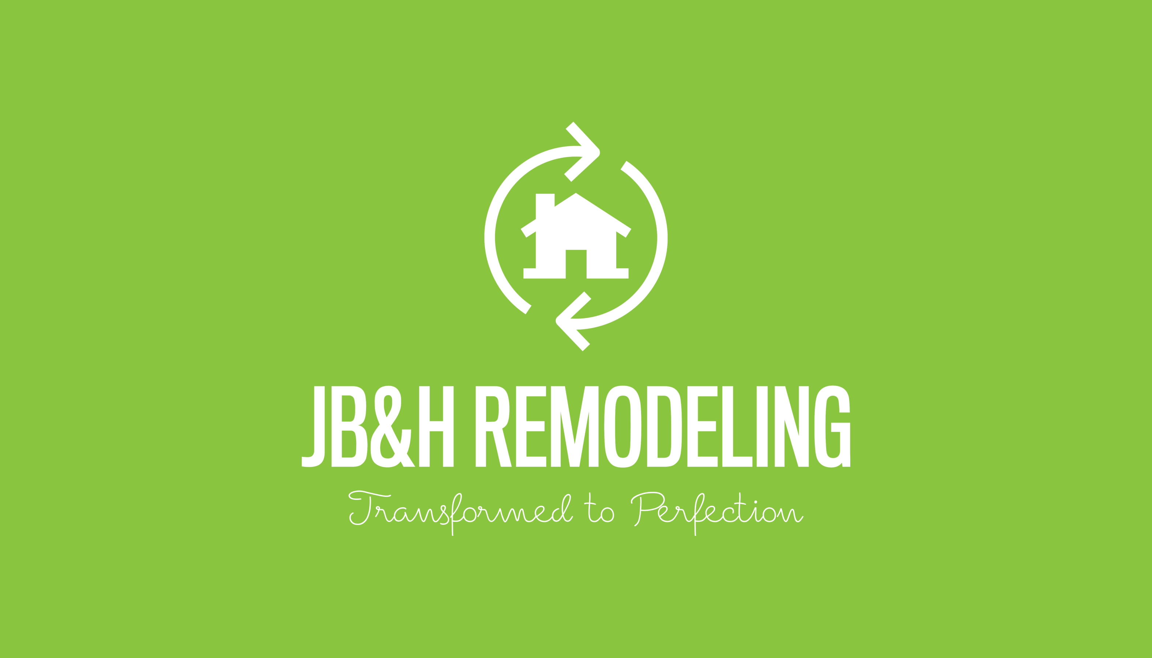
JB&H Remodeling
1753 Riverstone Pkwy
Suite 167
Canton, GA 30114
678-697-7754
james@jbhremodeling.com https://www.jbhremodeling.com
Project Contact Telephone Number: 678-697-7754
Project Name and Location:
Project Number: 610567
Project Manager: James Harris

Specifications of Project:
For the Amount of dollars
()

